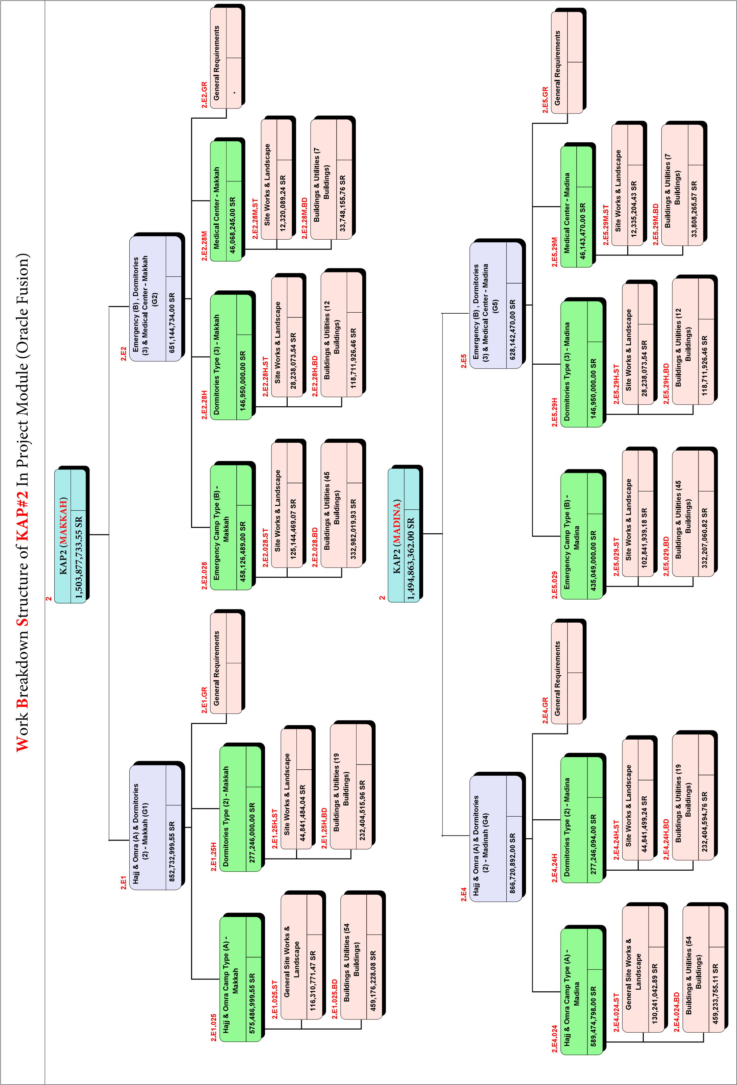

* **HC1 | 10259**
  + General
    - Section / Contract Milestones
      * Mockup / Benchmark
      * The Mound
      * The Ring
      * The Beach
      * The Tail
      * Time for Completion
    - Key / Control Milestones
      * Mockup / Benchmark
      * The Mound
      * The Ring
      * The Beach
      * The Tail
    - Mobilization
      * Contractor's Submissions
      * Mobilization & Site Establishment
    - Interface Milestones
      * Procurement
      * Approval of Detailed Engineering
      * Manufacturing & Delivery
      * Construction of Facilities
  + Engineering
    - BIM Models
      * Façade
    - Shop Drawings
      * Façade
    - Method Statements
      * Façade
  + Materials Procurement
    - Material Submission
      * Façade
    - Purchase Material
      * Batch No.01 (Mockup / Benchmark)
      * Batch No.02
    - Materials Fabrication & Delivery to Site
  + Construction
    - The Mound
    - The Ring
    - The Beach
    - The Tail
  + Close-Out / Handing Over
    - Testing & Commissioning
    - Snagging / De-Snagging
    - Authorities Inspections / Approvals
    - Close-out Documentation
    - Demobilization

1. Project Life Cycle
   1. Initializing (Starting) Operations Group
      1. Project Shop Drawing Preparation
      2. Project Scope Analyze
      3. Project Tasks & Resources Preparation
      4. Project Cost Structure Preparation
      5. Project Quality Control Methodologies & Check-Points
      6. Project Human Resources Specifying
      7. Project Communication Points Preparation
      8. Project Risk Assessment (Qualitative, Quantitate & Respond)
      9. Project Procurement Specifying
      10. Project Stake-Holders Specifying
   2. Planning Operations Group
      1. Project Plan Preparation
      2. Project Scope Planning & Partial Hierarchy
      3. Project Time Schedule & Activities, Tasks, Resources Planning
      4. Project Budgeting Preparation
      5. Project Quality Control Plan Preparation
      6. Project Human Resources Plan Preparation
      7. Project Communication Plan Preparation
      8. Project Risk Management Plan Preparation
      9. Project Procurement Plan Preparation
      10. Project Stake-Holders Plan Preparation
   3. Execution Operations Group
      1. Project Execution Access & Initialization
      2. Project QC Check-Points & Assurance
      3. Project HR Assignments & Team Management
      4. Project Stake-Holders Prospective Management
      5. Project Contracts Concluding
      6. Project Stake-Holders Participation
   4. Monitoring & Control Operations Group
      1. Project Monitoring & Control
      2. Project Scope Checks & Control
      3. Project Time Schedule Control
      4. Project Cost Control
      5. Project Quality Control
      6. Project HR Performance Control
      7. Project Communication Control
      8. Project Risk Control
      9. Project Procurement Control
      10. Project Stake-Holders Control Participation
   5. Ending (Closing) Operation Group
      1. Finalizing & Closing
      2. Project Stake-Holders Satisfaction of Quality
      3. Project Finalizing Party
      4. Project Procurement Closing